Show Start listening when start show stop listening when stop

s

xjddssss

VOICE TO TEXT 

LANGUAGE 

STOP LISTENING 

START LISTENING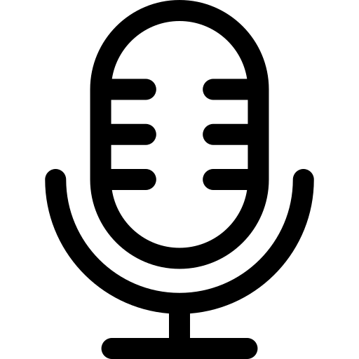

VOICE WRITEN TEXT 

**Clear section print section doc type section Download section**